Supplementary Information for

**Machine learning in additive manufacturing——NiTi alloy’s transformation behavior**

**The file includes:**

Supplementary Figures 2

Fig. S1: Powder composition and sample preparation 2

Fig. S2: Partitioning of the dataset for validation, testing, and prediction. 3

Fig. S3: DSC measurement curves for MF samples 4

Fig. S4: DSC measurement curves for SF samples 5

Fig. S5: EDS measurement results for MF samples 6

Fig. S6: EDS results for SF samples 7

Supplementary Tables 8

Table S1: Phase-transition temperature dataset and corresponding references 8

Table S2: Descriptors and their method of calculation 9

Table S3: Comparison of several hyperparameter optimization methods 10

Table S4: Sequence of feature descriptors extracted according to the RFE method 11

Table S4: the relative errors calculated from experimental and anticipated values for Ni50.8Ti49.2 12

Supplementary References 13

## Supplementary Figures

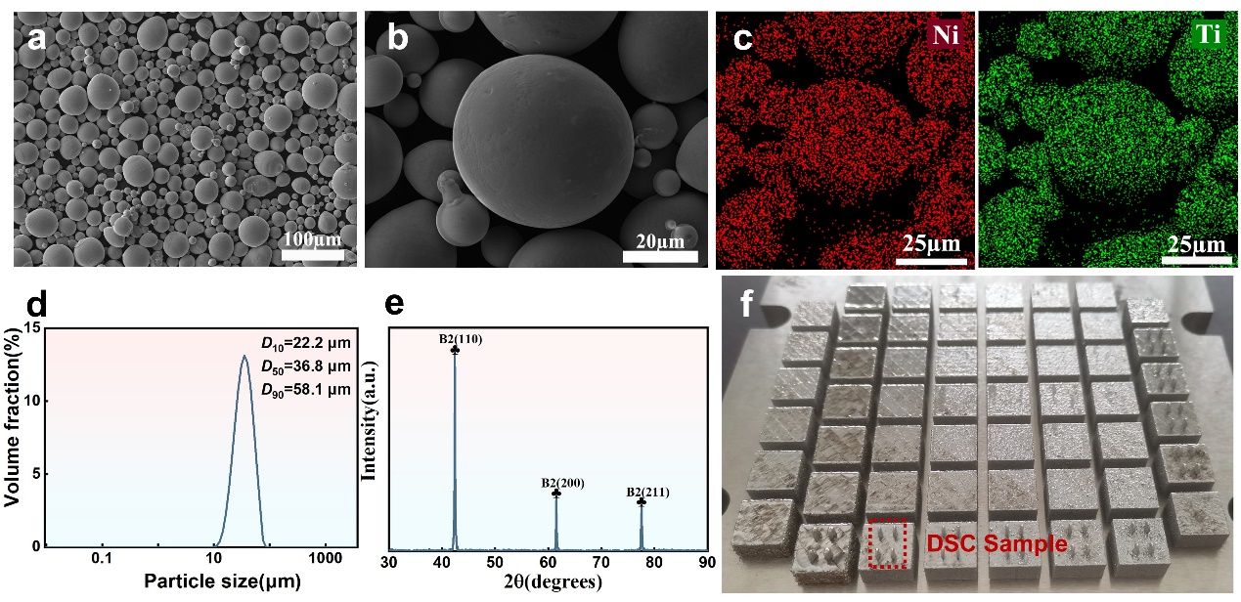

### Fig. S1: Powder composition and sample preparation

a) and b) Scanning Electron Microscopy (SEM) images of NiTi powder. c) Energy-Dispersive X-ray Spectroscopy (EDS) analysis of NiTi powder. d) Particle size distribution of NiTi powder. e) X-ray Diffraction (XRD) analysis of NiTi powder. f) NiTi sample preparation by Laser Powder Bed Fusion (LPBF); Samples marked in red font indicate Differential Scanning Calorimetry (DSC) samples.

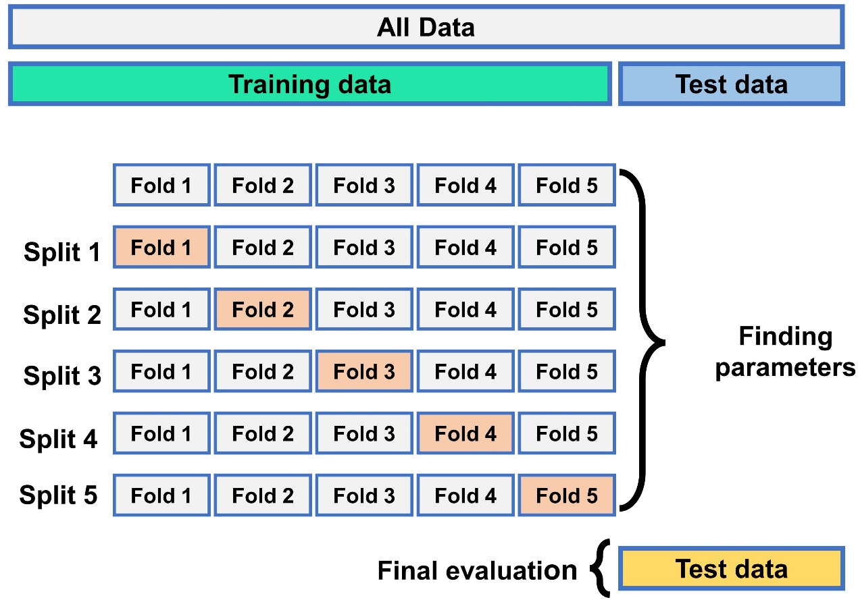

### Fig. S2: Partitioning of the dataset for validation, testing, and prediction.

Non-overlapping splits in a 5-fold cross-validation and benchmarking approach are employed for optimal hyperparameter determination and model testing2. In all datasets, 80% of the data is allocated for training cross-validation (CV) (indicated by green shading in Supplementary Figure 2), with the remaining 20% reserved for testing the model's performance (indicated by blue shading in Supplementary Figure 2). The entire dataset is utilized for the final model training, as shown in gray shading in Supplementary Figure 2, focusing on predicting NiTi phase transition temperatures. Evaluation of the model's unseen regions is based on the generalization and extrapolation capabilities of the selected architecture, using knowledge gained from the 5 distinct data subsets. The model's average performance across the five data subsets can be optimized by randomly selecting hyperparameters through multiple cross-validation iterations (with fixed hyperparameters for all subsets within one CV iteration)3.

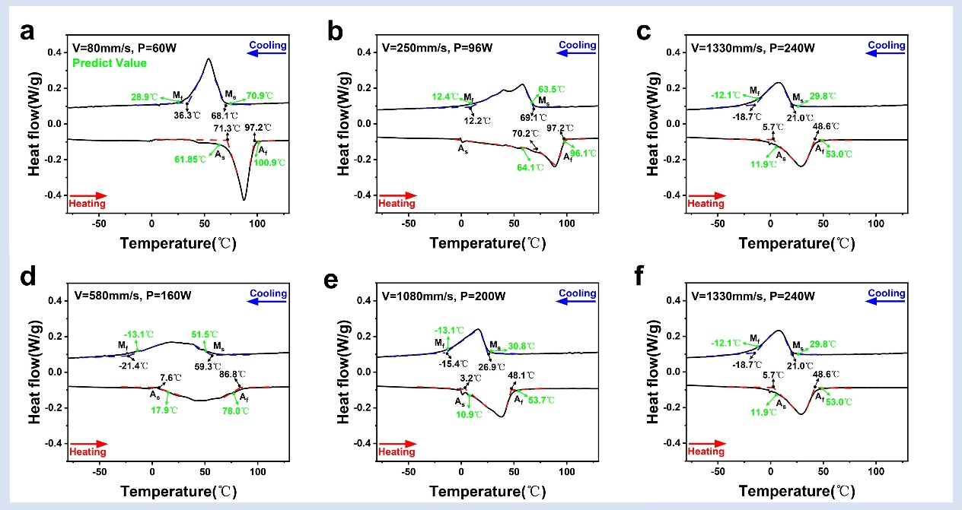

### Fig. S3: DSC measurement curves for MF samples

The green segment signifies the predicted values from the Generalized Regression Neural Network (GRNN) model. The figure indicates that low scanning speed and low power result in a higher phase transition temperature.

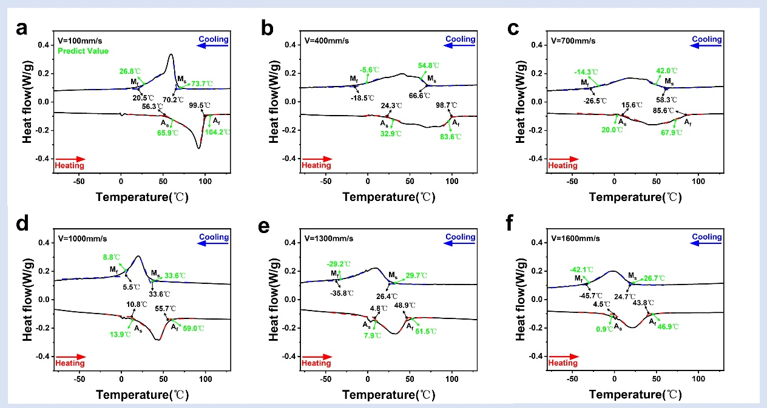

### Fig. S4: DSC measurement curves for SF samples

The green part represents the predicted value of the GRNN model. It can be seen that the lower scan speed has a higher temperature phase transition and the higher scan speed has a lower temperature phase transition.

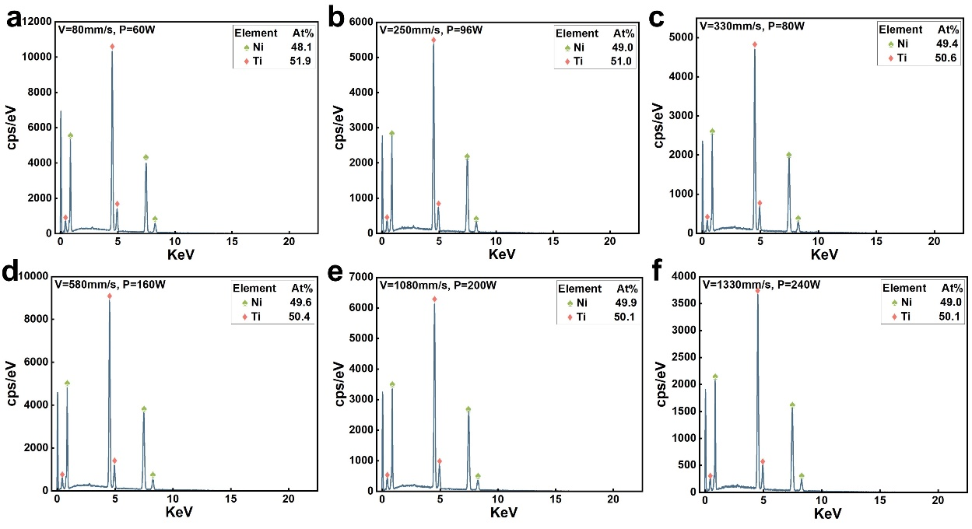

### Fig. S5: EDS measurement results for MF samples

Ni content (in green); Ti content (in red). The figure reveals that low scanning speed and low power result in reduced Ni content.

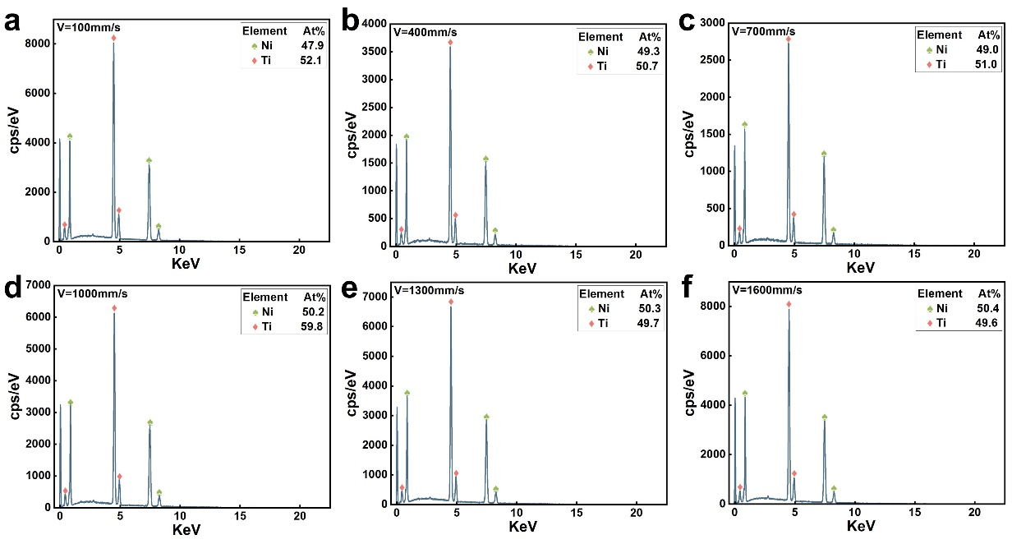

### Fig. S6: EDS results for SF samples

Ni content (in green) and Ti content (in red). Observably, samples with lower scanning speed exhibit reduced Ni content, while those with higher scanning speed demonstrate elevated Ni content. In summary, the Ni content is intricately linked to the phase transition temperature.

## Supplementary Tables

### Table S1: Phase-transition temperature dataset and corresponding references

See Phase-transition database.xlsx

### Table S2: Descriptors and their method of calculation

|  |  |  |  |
| --- | --- | --- | --- |
| Group | | Descriptors | Method of obtaining descriptors |
| Descriptors of powder |  | Particle size (D:10,50,90, max, min) (µm)  Composition Ni,Ti(at%) | Obtained from the manufacturer |
| Descriptors of LPBF process parameters1 | | Laser power P (W) | Obtained from literature and experiments |
| Scanning speed V (mm/s) |
| Scanning space h(µm) |
| Layer thickness t(µm) |
| Linear energy density EL (J/mm) |  |
| Surface energy density ES (J/mm2) |  |
| Volume energy density EV (J/mm3) |  |

### Table S3: Comparison of several hyperparameter optimization methods

|  |  |  |  |  |
| --- | --- | --- | --- | --- |
| **Method** | **Train(s)** | **Test(s)** | **Overall(s)** | **Average R2** |
| Grid Search | 100.7 | 0.6 | 101.3 | 0.92 |
| Random Search | 6.2 | 0.8 | 7.0 | 0.88 |
| Bayesian Optimization | 81.3 | 0.9 | 103.6 | 0.97 |

### 

### Table S4: Sequence of feature descriptors extracted according to the FRE method

|  |  |  |  |  |  |  |  |  |  |  |  |  |
| --- | --- | --- | --- | --- | --- | --- | --- | --- | --- | --- | --- | --- |
| **Iterations** | **Sequence of feature descriptors** | | | | | | | | | | | |
| 1 | EL |  |  |  |  |  |  |  |  |  |  |  |
| 2 | EL | V |  |  |  |  |  |  |  |  |  |  |
| 3 | EL | V | EV |  |  |  |  |  |  |  |  |  |
| 4 | EL | V | EV | Dmin |  |  |  |  |  |  |  |  |
| 5 | EL | V | EV | Dmin | Dmax |  |  |  |  |  |  |  |
| 6 | EL | V | EV | Dmin | Dmax | Ni |  |  |  |  |  |  |
| 7 | EL | V | EV | Dmin | Dmax | Ni | P |  |  |  |  |  |
| 8 | EL | V | EV | Dmin | Dmax | Ni | P | h |  |  |  |  |
| 9 | EL | V | EV | Dmin | Dmax | Ni | P | h | D10 |  |  |  |
| 10 | EL | V | EV | Dmin | Dmax | Ni | P | h | D10 | D90 |  |  |
| 11 | EL | V | EV | Dmin | Dmax | Ni | P | h | D10 | D90 | t |  |
| 12 | EL | V | EV | Dmin | Dmax | Ni | P | h | D10 | D90 | t | D50 |

The X-axis in Fig. 2c corresponds to each other.

### Table S5: the relative errors calculated from experimental and anticipated values for Ni50.8Ti49.2

|  |  |  |  |  |  |  |  |  |  |  |  |  |  |  |  |  |  |
| --- | --- | --- | --- | --- | --- | --- | --- | --- | --- | --- | --- | --- | --- | --- | --- | --- | --- |
| **Sample** | **V** | **P** | **h** | **t** | **Energy Density EV** | **Experiment** | | | | **Predict** | | | | **Ms_err(%)** | **Mf_err(%)** | **As_err(%)** | **Af_err(%)** |
| **Ms** | **Mf** | **As** | **Af** | **Ms** | **Mf** | **As** | **Af** |
| #1 | 80 | 60 | 120 | 30 | 208.3 | 341 | 309 | 344 | 370 | 344 | 302 | 335 | 374 | 0.88 | 2.27 | 2.62 | 1.08 |
| #2 | 250 | 96 | 100 | 30 | 128.0 | 342 | 285 | 343 | 370 | 337 | 286 | 337 | 369 | 1.46 | 0.35 | 1.75 | 0.27 |
| #3 | 330 | 80 | 80 | 30 | 101.0 | 341 | 295 | 329 | 370 | 333 | 280 | 315 | 362 | 2.35 | 5.08 | 4.26 | 2.16 |
| #4 | 580 | 160 | 110 | 30 | 83.6 | 332 | 252 | 280 | 360 | 325 | 260 | 291 | 351 | 2.11 | 3.17 | 3.93 | 2.50 |
| #5 | 1080 | 200 | 80 | 30 | 77.2 | 300 | 258 | 281 | 321 | 304 | 260 | 284 | 327 | 1.33 | 0.78 | 1.07 | 1.87 |
| #6 | 1330 | 240 | 80 | 30 | 75.2 | 294 | 254 | 276 | 316 | 303 | 261 | 285 | 326 | 3.06 | 2.76 | 3.26 | 3.16 |
| #7 | 100 | 125 | 80 | 30 | 520.8 | 343 | 294 | 330 | 373 | 347 | 300 | 339 | 378 | 1.17 | 2.04 | 2.73 | 1.34 |
| #8 | 400 | 125 | 80 | 30 | 130.2 | 340 | 255 | 297 | 368 | 328 | 268 | 306 | 357 | 3.53 | 5.10 | 3.03 | 2.99 |
| #9 | 700 | 125 | 80 | 30 | 74.4 | 331 | 247 | 300 | 359 | 315 | 259 | 293 | 341 | 4.83 | 4.86 | 2.33 | 5.01 |
| #10 | 1000 | 125 | 80 | 30 | 52.1 | 307 | 279 | 284 | 329 | 307 | 282 | 287 | 332 | 0.00 | 1.08 | 1.06 | 0.91 |
| #11 | 1300 | 125 | 80 | 30 | 40.1 | 300 | 237 | 279 | 322 | 303 | 244 | 281 | 325 | 1.00 | 2.95 | 0.72 | 0.93 |
| #12 | 1600 | 125 | 80 | 30 | 32.6 | 298 | 227 | 278 | 317 | 300 | 231 | 274 | 320 | 0.67 | 1.76 | 1.44 | 0.95 |

## Supplementary References

1. Mahmoudi, M., Tapia, G., Franco, B., Ma, J., Arroyave, R., Karaman, I., and Elwany, A. (2018). On the printability and transformation behavior of nickel-titanium shape memory alloys fabricated using laser powder-bed fusion additive manufacturing. Journal of Manufacturing Processes *35*, 672–680. 10.1016/j.jmapro.2018.08.037.

2. Deng, Z., Yin, H., Jiang, X., Zhang, C., Zhang, K., Zhang, T., Xu, B., Zheng, Q., and Qu, X. (2018). Machine leaning aided study of sintered density in Cu-Al alloy. Computational Materials Science *155*, 48–54. 10.1016/j.commatsci.2018.07.049.

3. Jafari Gukeh, M., Moitra, S., Ibrahim, A.N., Derrible, S., and Megaridis, C.M. (2021). Machine Learning Prediction of TiO 2 -Coating Wettability Tuned via UV Exposure. ACS Appl. Mater. Interfaces *13*, 46171–46179. 10.1021/acsami.1c13262.